Planning

Front-end application:
C# in Visual Studio

Back-end database:
SQL in MySQL

Data/fields:

Flight: flight number[PK], departing from, landing at, departure date, arrival date, ticket price

Hotel: hotel number[PK], location, capacity, Room Number Booked, price per night

insurance : insurance number[PK], ,price

Car hire: car number[PK],hire start date, hire end date, price

Customer: idcustomer[PK], name, flight number[FK], hotel number[FK], insurance number[FK], car number[FK].

We need to keep track of rooms and availability i think, also i don’t think we need to keep track of flights/cars to anywhere near this level of detail for a hotel booking company (we’re not an all in one package holiday provider).

Feel free to change any of the data, i was just jotting down random stuff - cool.. A good start of fields though
Sounds good to me! The simpler the better! (Clive)

Agreed RULE: Every holiday is a package with 2x Adults & 2xChildren

Documentation Needed:
Requirements Spec.
Overview : System Diagram- & explanation of purpose (to integrate the 2 systems)
ERD
Connection We will need to agree a method of connection (internet, ethernet, file upload to 1 visual studio etc…)
Test Plans
Proposed design (example information)
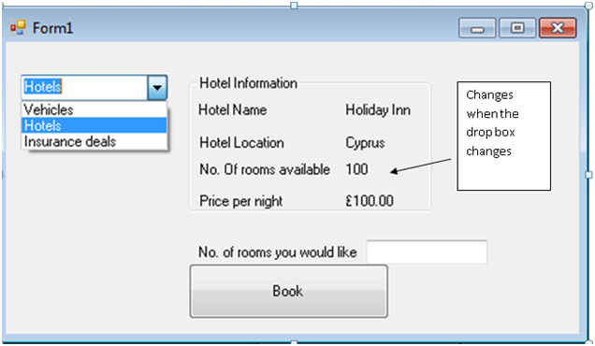

This is the general framework for the application so far
https://github.com/boacompiler/GroupSystemsIntegrationAssignment
Check out this folder for the main classes BookingBackend.cs will be the class which handles retrieving info and making bookings for the frontend team. Bear in mind when requesting a hotel, a hotel class will be returned.

https://github.com/boacompiler/GroupSystemsIntegrationAssignment/tree/master/assignmenttest/Backend

Database final tables

HOTEL
Idhotel (int 11)
hotel_name (VARCHAR 45)
star_rating ENUM (‘1’,’2’,’3’,’4’,’5’)
description (VARCHAR 100)
address (VARCHAR 100)

ROOM
idroom (INT 11)
[fk] idhotel (INT 11)
price_pn (FLOAT)
name (VARCHAR 45)
details (VARCHAR 45) <- clive you have not implemented this yet

BOOKING
Idbooking (INT 11)
[fk] idroom (INT 11)
date_begin (DATE)
date_ end (DATE)
[fk]billable_ person (INT 11)

BOOKINGITEMS
[fk] billable_ item (INT 11)
[fk] idbooking (INT 11)

PERSON
idperson (INT 11)
[fk] idbooking(INT 11) !!! this field is redundant due to booking tables fk, i’m ignoring it
first _name(VARCHAR 20)
second_name(VARCHAR30)
contact_ details (VARCHAR 45)
billing details / we don't need these (NOT IMPLEMENTED)

BILLABLE ITEM
idbillable_items (INT 11)
name(VARCHAR 20)
item_description(VARCHAR 30)
price(FLOAT)

